Polish Expressionism

In contrast to the German movement, Polish Expressionism did not involve a whole generation of artists but only a small part of it. Historical Expressionism (1910-25) played only a marginal role in Polish artistic life; more important was the early, symbolist EXPRESSIONISM at the turn from the 19th to the 20th century with its affinity for hyperboles and grotesque expressions in the prose and poetry of Jan Kasprowicz, Tadeusz Miciński, Wacław Berent and Roman Jaworski. In the visual arts, it was characterised by an anti-naturalist deformation of space and the use of colour accompanied by existential themes in the works of Władysław Podkowiński and Stanisław Wyspiański. Unique in this context are the abstract, ‘musical’ compositions of the Warsaw painter Mikalojus Čiurlionis. The work of EDVARD MUNCH and Gustav Vigeland popularised by Stanisław Przybyszewski provided an important influence for artists such as Wojciech Weiss, Xawery Dunikowski and Franciszek Flaum. Przybyszewski played a stimulating role in the biweekly Zdrój (Source, 1917-22, edited by Jerzy Hulewicz in Poznań), a leading forum of the only programmatic Expressionist circle in Poland. This artist group included Margarete and Stanisław Kubicki, Władysław Skotarek, Stefan Szmaj and other less radical artists who programmatically used the bilingual name Bunt (Polish – Revolt, German – colourful, 1917-22) and employed linocut as an egalitarian artistic medium.

The Kubickis and Hulewicz also produced the earliest examples of ABSTRACT ART in Poland. The first group exhibition in April 1918 was a success de scandal because of its social and political provocation, promoting sexual liberation and international spirit in a traditional and national oriented milieu. The second exhibition was organised at the Berlin gallery Die Aktion in June. The following three shows in Poznań and Lvov in 1919 and 1920 where organised in collaboration with the Formiści group (Formists, 1917-22) from Cracow and Young Yiddish (1919-22) from Łódź (see YIDDISH AVANT-GARDE). While Young Yiddish, like Bunt, was engaged in international leftist artistic activities, Formiści concentrated on formal questions, which initiated Art Déco, a Polish national style inspired by folk art, and distanced itself from any German connotations. While some artists of Bunt and Young Yiddish, who eventually became members of INTERNATIONAL CONSTRUCTIVISM, cooperated with Der Sturm and participated in the Congress of the International Union of Progressive Artists in Düsseldorf and the International Exhibition of Revolutionary Artists organised by the Kubickis in Berlin in 1922, the writers of Zdrój with Jan Stur, like Formiści, tended to favour a Polonisation of expressionism by looking for its genealogy in the Polish romantic tradition. The anthology of the movement was Zmierzch Epoki (Twilight of the Epoch, 1920).

Expressionism was also present as literary poetics in manifestations of Polish FUTURISM and DADAISM in Cracow and Warsaw. In the visual arts, it included the work of some POLISH representatives of the ÉCOLE DE PARIS, among them Eli Nadelmann and Alfred Aberdam. The art works of Stanisław Ignacy Witkiewicz and the poetry of Józef Wittlin and the group Czartak (1922-28, founded by Emil Zegadłowicz) contained an original Polish contribution to late Expressionism.

References and further readings:

Marek Bartelik, Early Polish modern Art. Unity in multiplicity, Manchester/New York: Manchester University Press, 2005.

Timothy O. Benson (ed.), Central European Avant-Gardes: Exchange and Transformation, 1910-1930, Cambridge, Mass./London: The MIT Press, 2002.

Lidia Głuchowska, Polish and Polish-Jewish Modern and Avant-Garde artists in the ‘Capital of the United States of Europe’, c. 1910-1930, Centropa, Sept. 2012 (forthcoming).

Piotr Łukaszewicz, Jerzy Malinowski, Ekspresjonizm w sztuce polskiej, Wrocław: Muzeum Narodowe, 1980.

Józef Ratajczak (ed.), Krzyk i ekstaza. Antologia polskiego ekspresjonizmu, Poznań: Wydawnictwo Poznańskie, 1897.

Suggested images:
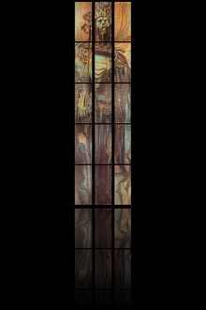
1. Stanisław Wyspiański, Kazimierz Wielki, pastel, project of the stained glass for the cathedral in Cracow, 1904, National Museum Cracow.

http://www.imnk.pl/gallerybox.php?dir=XX079

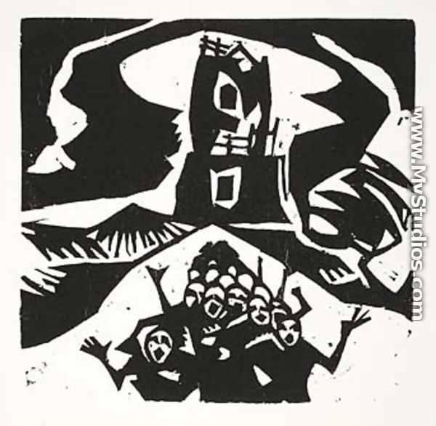
Stanisław Kubicki, The Tower of Babel, linocut, c. 1918, Coll. Kubicki, Berlin

http://www.mystudios.com/artgallery/S/Stanislaw-Kubicki/Tower-of-Babel.html

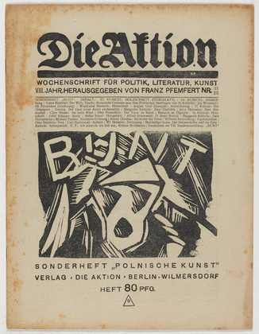
Stanislaw Kubicki, Bunt (The revolt), linocut, 1918 at the cover of the magazine Die Aktion 21/22, 1918 entitled Polnische Kunst (Polish Art), The Moma Collection, New York

http://www.moma.org/collection_images/resized/472/w500h420/CRI_245472.jpg

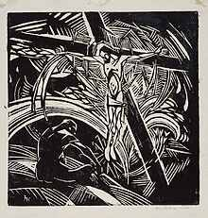
Jerzy Hulewicz, The Cross, linocut, c. 1918, National Museum of Warsaw

http://upload.wikimedia.org/wikipedia/commons/2/2a/Hulewicz-krzyz.jpg

